Show Your School Spirit with University Meadows School Clothing!
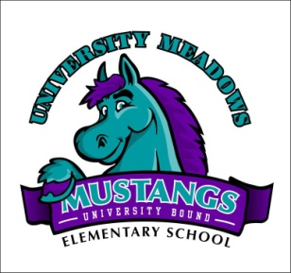
NEW DESIGN FOR 2014!!!!!!
Short sleeve T-shirts with the University Meadows logo are available in both children’s and adult sizes with the above logo. Prices, colors, and sizes are listed below. We also have car magnets! Please contact the PTA with any questions at umes_pta@yahoo.com
Orders are placed at the end of each month!! Wear your school clothing every FRIDAY to show your school spirit!
Order Form
Short Sleeve T-shirt LONG SLEEVE IS AVAILABLE!! ADD $2.00 to each PRICE !!
Children’s Sizes Cost Color & Quantity
____Small (6-8) $10 ___Purple ___White _____Teal _____Black **Specify if Long Sleeve ___________
____Medium(10-12) $10 ___Purple ___White _____Teal _____Black
____Large(14-16) $10 ___Purple ___White _____Teal _____Black

Adult Sizes Cost Color & Quantity Pullover Hooded Sweatshirt Cost: 30.00
___Small $12 ___Purple ___White ______Teal ______Black Available in all the colors shown and Adult sizes
___Medium $12 ___Purple ___White _____ Teal _____ Black Add $5.00 for Hooded sizes larger than
___Large $12 ___Purple ___White _____ Teal _____ Black XLarge Size _____ Color____________
___X-Large $12 ___Purple ___White _____Teal _____ Black
___XX-Large $15 ___Purple ___White _____Teal ______Black
___XXX-Large $15 ___Purple ___White _____Teal ______ Black
Other Items
____Car Magnet $4
Please include payment (cash only) and return to your child’s teacher. Your order will be filled and sent home with your child. Thank you for your support of our school!
Child’s Name:________________________________________Home Phone:__________________________________________
Email Address:__________________________________________________________________________________________________
Teacher:______________________________________Grade:_______________Total Enclosed:_________________________

